**Project Design Phase-II**

**Data Flow Diagram & User Stories**

|  |  |
| --- | --- |
| Date | 26 February 2026 |
| Team ID | LTVIP2026TMIDS41542 |
| Project Name | ShopSmart:Your Digital Grocery Store Experience |
| Maximum Marks | 4 Marks |

**Data Flow Diagrams:**

A Data Flow Diagram (DFD) is a traditional visual representation of the information flows within a system. A neat and clear DFD can depict the right amount of the system requirement graphically. It shows how data enters and leaves the system, what changes the information, and where data is stored.

**DFD Level 0:** 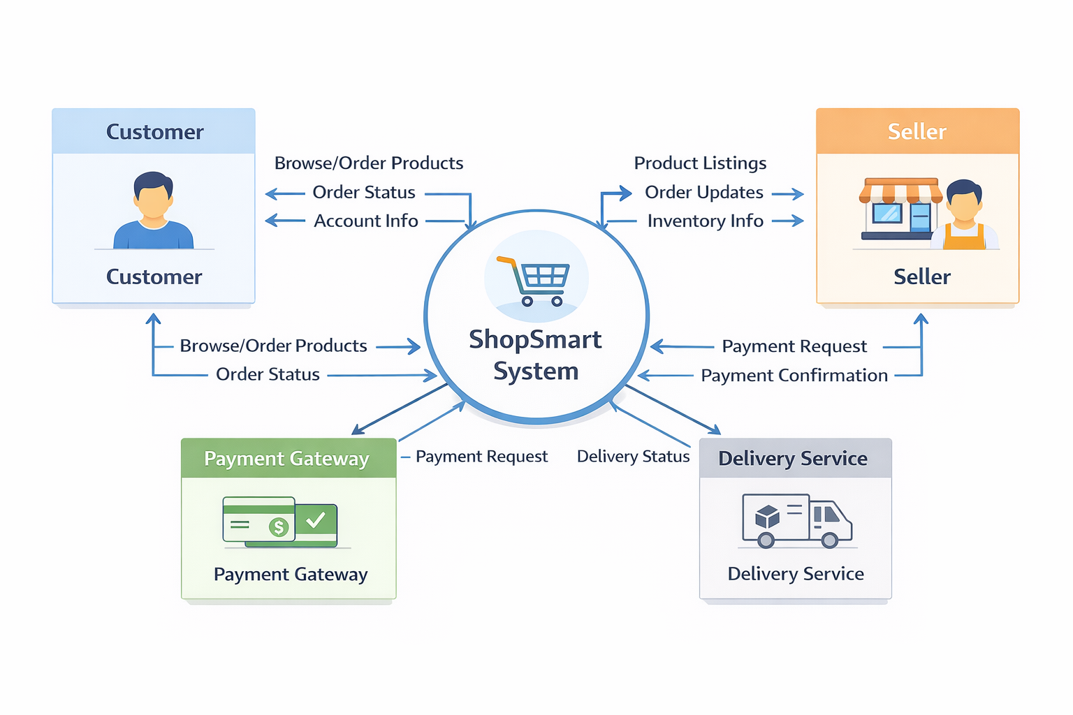

**DFD Level 1:**

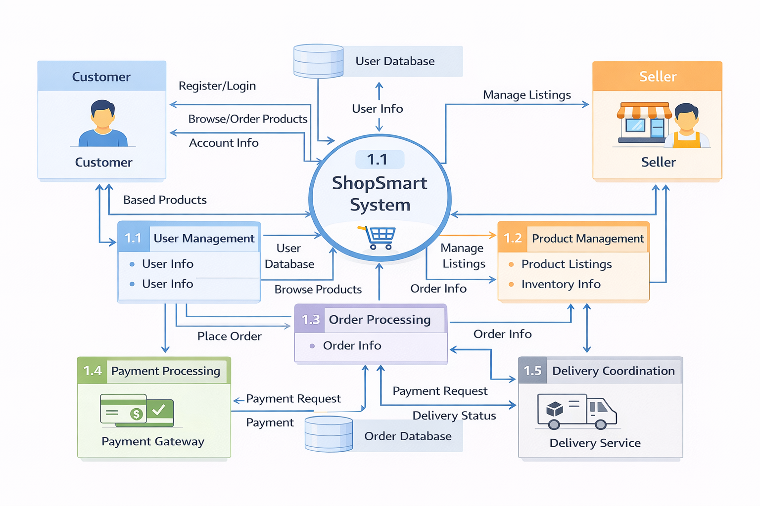

**DFD Level 2:**

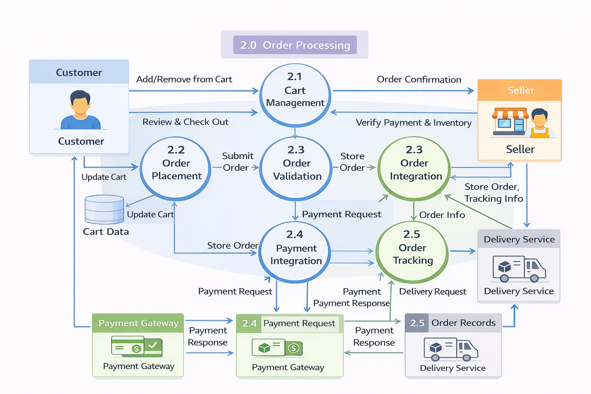

**User Stories**

**Use the below template to list all the user stories for the product.**

| **User Type** | **Functional Requirement (Epic)** | **User Story Number** | **User Story / Task** | **Acceptance Criteria** | **Priority** | **Release** |
| --- | --- | --- | --- | --- | --- | --- |
| **Customer (Mobile user)** | **Registration** | **USN-1** | **As a user, I can register using email, password, and confirm password.** | **Account is created and user is redirected to dashboard/home.** | **High** | **Sprint-1** |
| **Customer (Mobile user)** | **Registration** | **USN-2** | **As a user, I will receive confirmation email once I have registered for the application.** | **User receives confirmation email and can verify account from link/code.** | **High** | **Sprint-1** |
| **Customer (Mobile user)** | **Registration** | **USN-3** | **As a user, I can register for the application through Facebook.** | **User can sign up/login and access dashboard with Facebook account.** | **Low** | **Sprint-2** |
| **Customer (Mobile user)** | **Registration** | **USN-4** | **As a user, I can register for the application through Google.** | **User can sign up/login and access dashboard with Google account.** | **Medium** | **Sprint-1** |
| **Customer (Mobile user)** | **Login** | **USN-5** | **As a user, I can log into the application by entering email & password.** | **Valid credentials log user in and open home/dashboard.** | **High** | **Sprint-1** |
| **Customer (Mobile user)** | **Dashboard** | **USN-6** | **As a user, I can view featured products and top sellers on dashboard.** | **Dashboard shows product list, seller cards, and quick navigation.** | **High** | **Sprint-1** |
| **Customer (Mobile user)** | **Product Discovery** | **USN-7** | **As a user, I can search products/sellers by name or category.** | **Search returns relevant results with clear empty-state if none found.** | **High** | **Sprint-1** |
| **Customer (Mobile user)** | **Cart & Checkout** | **USN-8** | **As a user, I can add items to cart and update quantity.** | **Cart updates totals in real time and persists for logged-in user.** | **High** | **Sprint-1** |
| **Customer (Mobile user)** | **Orders** | **USN-9** | **As a user, I can place an order from my cart.** | **Order is created successfully and order ID is generated.** | **High** | **Sprint-1** |
| **Customer (Mobile user)** | **Payments** | **USN-10** | **As a user, I can pay online for my order.** | **Payment is processed and status is saved against order.** | **High** | **Sprint-1** |
| **Customer (Mobile user)** | **Order Tracking** | **USN-11** | **As a user, I can track my order status from placed to delivered.** | **Status timeline updates through defined order lifecycle.** | **High** | **Sprint-1** |
| **Customer (Mobile user)** | **Reviews** | **USN-12** | **As a user, I can rate and review delivered products.** | **User can add/update/delete own review; average rating refreshes.** | **Medium** | **Sprint-2** |
| **Customer (Web user)** | **Authentication** | **USN-13** | **As a web user, I can register and login with email/password.** | **User session starts and protected pages are accessible.** | **High** | **Sprint-1** |
| **Customer (Web user)** | **Product Browsing** | **USN-14** | **As a web user, I can browse all products and sellers.** | **User can open product/seller details and view available items.** | **High** | **Sprint-1** |
| **Customer (Web user)** | **Checkout** | **USN-15** | **As a web user, I can checkout with cart summary and delivery address.** | **Address validation works and order is created only with valid inputs.** | **High** | **Sprint-2** |
| **Customer (Web user)** | **Order History** | **USN-16** | **As a web user, I can view my past orders.** | **Order history shows status, amount, and order date details.** | **Medium** | **Sprint-2** |
| **Customer (Web user)** | **Profile** | **USN-17** | **As a web user, I can update my profile and profile image.** | **Updated profile fields are saved and reflected immediately.** | **Medium** | **Sprint-2** |
| **Customer (Web user)** | **Support Operations** | **USN-18** | **As a support executive, I can search customers and orders by ID/email/phone.** | **Search returns correct records with pagination and filters.** | **High** | **Sprint-2** |
| **Customer (Web user)** | **Complaint Handling** | **USN-19** | **As a support executive, I can create and update complaint tickets.** | **Ticket status and notes are saved with timestamp and owner.** | **High** | **Sprint-2** |
| **Customer (Web user)** | **Order Assistance** | **USN-20** | **As a support executive, I can view full order timeline for customer queries.** | **Timeline includes all status transitions and payment state.** | **High** | **Sprint-2** |
| **Customer (Web user)** | **Escalations** | **USN-21** | **As a support executive, I can escalate unresolved cases to admin.** | **Escalation is tagged, assigned, and visible in admin queue.** | **Medium** | **Sprint-3** |
| **Customer (Web user)** | **Refund Support** | **USN-22** | **As a support executive, I can initiate refund requests for failed/cancelled orders.** | **Refund request is logged and moves through approval workflow.** | **Medium** | **Sprint-3** |
| **Administrator** | **Access & Security** | **USN-23** | **As an admin, I can login securely and access admin dashboard only with admin role.** | **Non-admin users are blocked from admin routes.** | **High** | **Sprint-1** |
| **Administrator** | **Dashboard Analytics** | **USN-24** | **As an admin, I can view platform KPIs (orders, users, revenue, status distribution).** | **Dashboard loads accurate metrics and 7-day analytics.** | **High** | **Sprint-1** |
| **Administrator** | **User Management** | **USN-25** | **As an admin, I can view users and change status (active/inactive/banned).** | **User list supports search/pagination; status changes persist.** | **High** | **Sprint-1** |
| **Administrator** | **Seller Approval** | **USN-26** | **As an admin, I can approve or reject seller registrations.** | **Seller state updates immediately and action is auditable.** | **High** | **Sprint-1** |
| **Administrator** | **Order Governance** | **USN-27** | **As an admin, I can view and update any order status when required.** | **Admin status update reflects in order timeline and history.** | **Medium** | **Sprint-1** |
| **Administrator** | **Data Management** | **USN-28** | **As an admin, I can delete fraudulent or invalid users/orders.** | **Delete action requires confirmation and record is removed safely.** | **Medium** | **Sprint-2** |
| **Administrator** | **Product Governance** | **USN-29** | **As an admin, I can monitor and manage products across sellers.** | **Admin can view/edit/remove items violating policy.** | **Medium** | **Sprint-2** |
| **Administrator** | **Staff Governance** | **USN-30** | **As an admin, I can monitor staff accounts and approval flows.** | **Staff state and invite/approval records are viewable and editable.** | **Medium** | **Sprint-2** |
| **Administrator** | **Subscription Management** | **USN-31** | **As an admin, I can track plan usage and subscription revenue.** | **Plan-wise metrics and seller usage limits are visible.** | **Medium** | **Sprint-2** |
| **Administrator** | **Verification Monitoring** | **USN-32** | **As an admin, I can monitor email/SMS verification outcomes.** | **Verification logs show success/failure and resend attempts.** | **Low** | **Sprint-3** |